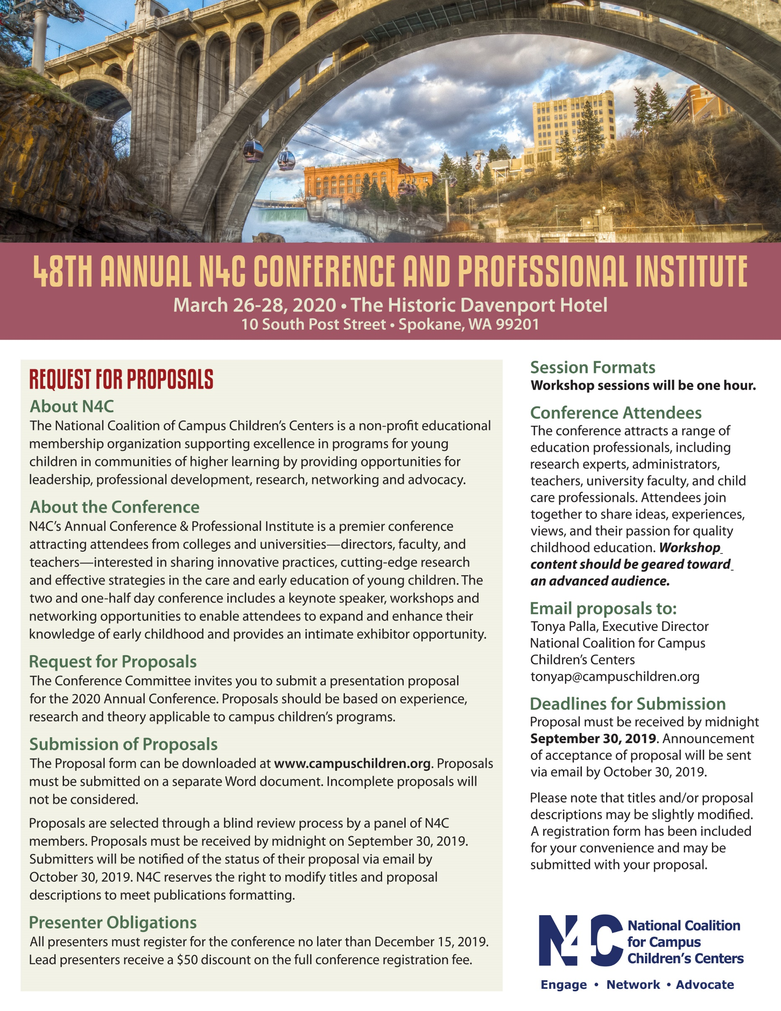

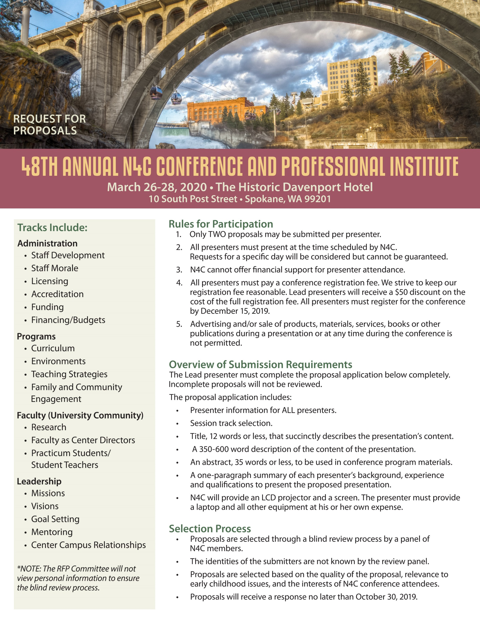

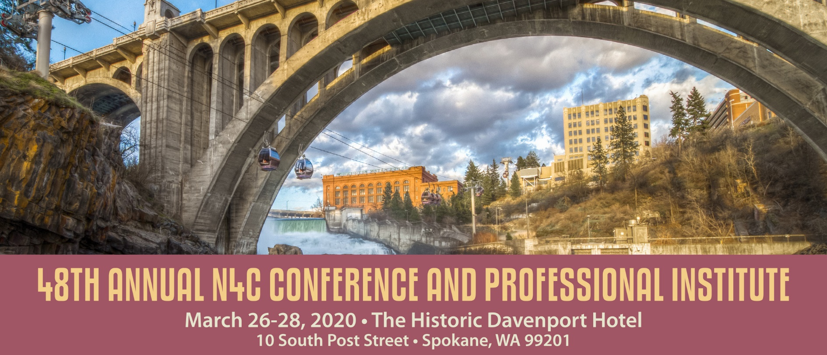
Request for Proposals
Please answer these questions below.
SECTION 1: Presenter Information
All presenters must complete this information. Please include professional designation after your name.
Lead Presenter’s Name and Title: Click here to enter text.
Co-presenter(s)’ Name(s) and Title(s): Click here to enter text.
1) Click here to enter text.
2) Click here to enter text.
3) Click here to enter text.
Organization/University: Click here to enter text.
Lead Presenter’s Mailing Address/City/State/Zip Click here to enter text.
Lead Presenter’s Office Phone: Click here to enter text. Fax: Click here to enter text.
Emails of All Presenters:
1) Click here to enter text.
2) Click here to enter text.
3) Click here to enter text.
Do you have a preferred day for presenting? ☐YES or ☐NO
Choose which day: ☐THURS. ☐FRI. ☐SAT.) We will try to respect your request but please keep in mind that these days CANNOT be guaranteed. The conference will run all day Thursday, Friday and half day Saturday.
Do you have special needs that we can assist you with? Click here to enter text.

SECTION 2: Audio Visual Equipment - N4C Guidelines
All presenters will receive a screen and LCD projector free of charge. The presenter MUST bring his or her own laptop if required for the presentation. All other equipment should be ordered through the hotel’s audiovisual company including sound, DVD and/or CD players or Internet connections.
SECTION 3: Track
Which track is the best fit for your session?
Please choose one: ☐Administration ☐Programs ☐Faculty (University Community) ☐Leadership
SECTION 4: Proposal Title
Title for your presentation: Click here to enter text.
Titles are limited to 12 words. N4C reserves the right to abbreviate titles if necessary. The title should clearly indicate the topic of the presentation.
SECTION 5: Proposal Description and Abstract
ALL 4 items listed below MUST be included in the PROPOSAL DESCRIPTION (350-600 words). Incomplete Proposal Descriptions will not be reviewed.
• The goal and/or purpose of the presentation.
• The relevance of the topic to early childhood education.
• A brief description of the presentation’s overall content, including any major theories, philosophies, and approaches that
will be highlighted.
• A minimum of three learning outcomes.
The ABSTRACT must be 35 words or less. It will be used in conference program materials.
Click here to enter text.

SECTION 6: Qualification Summary
A brief one- paragraph summary of the qualifications, both experience and education, that qualifies EACH presenter to present this.
Click here to enter text.

Deadlines for Submission
Proposal must be received by September 30, 2019. Announcement of acceptance of proposal will be sent via email by October 30, 2019. Please note that titles and/or proposal descriptions may be slightly modified.
Submission of Proposals
All proposals must be submitted electronically in the format outlined above and will be selected by a blind review process. Incomplete proposals will not be considered. Presenters will be notified by October 30, 2019.
Conference Registration
All workshop presenters are required to register and pay for the conference. There will be a $50 discount for the Lead Presenter on the cost of the full registration. A registration form has been included for your convenience and may be submitted with your proposal.
Email proposals to:
Tonya Palla, Executive Director
National Coalition for Campus Children’s Centers
(615) 614-3723
tonyap@campuschildren.org
Only proposals adhering to the guidelines and postmarked, or electronically date-stamped, by midnight September 30, 2019 will be considered/reviewed. N4C’s Conference program determines the number of proposals that will be selected. Having presented at previous N4C conferences does not guarantee selection for 2020. SPACE IS LIMITED.

